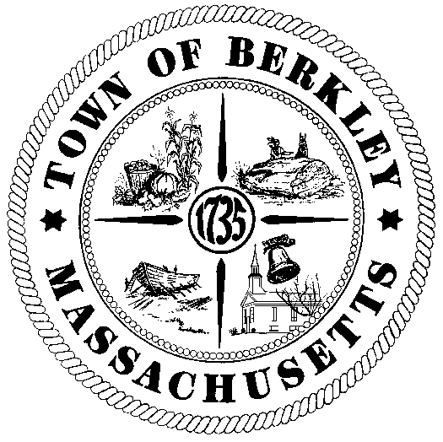

**TOWN OF BERKLEY**

# MASSACHUSETTS

# Town Administrator

One North Main Street 02779-1336

Office: 508-824-6794

Fax: 508-822-4603

E-mail: [selectmen@berkleyma.us](mailto:selectmen@berkleyma.us)

Townofberkleyma.com

To:     Town of Berkley Department Heads; Citizens

From: Matthew Chabot, Town Administrator

Date:  August 21, 2024

RE:    MGL Chapter 53, Section 18B; Arguments against Debt Exclusion

To All:

On June 3rd, 2024, the citizens of Berkley accepted the aforementioned state statute which allows a printed sheet of information on a ballot question to be mailed to each household in Town. The sheet must present arguments of 150 words or less that are “for” and “against” the question.

This office, in conjunction with Counsel, is seeking arguments *against* the ballot question that will appear on the Tuesday, November 5th, 2024 Presidential Election Ballot. The full text of the question was approved by the Berkley Board of Selectmen on June 26, 2024 as follows:

*“Shall the Town of Berkley be allowed to exempt from the provisions of proposition two-and-one-half, so called, the amounts required to pay for the bonds issued in order to pay costs of designing, constructing, equipping, and furnishing a new Berkley Community School, located at 59 South Main Street, Berkley, Massachusetts, and for the payment of all other costs incidental and related thereto?*

*Yes___ No____*

Please submit arguments in writing to the Town Administrator and the Town Clerk’s office prior to the end of business on Thursday, October 3rd, 2024.

Please direct any questions or clarifications to the office of Town Administrator.

Sincerely,

Matthew Chabot

Town Administrator