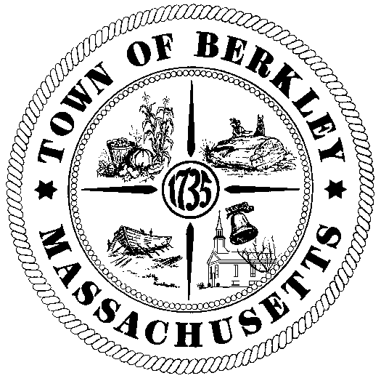
TOWN OF BERKLEY

Office of the Town Administrator
1 North Main Street
Berkley, Ma 02779

Selectmen@BerkleyMa.us

Phone: 774-501-0350 Fax: 508-822-4603

November 19th, 2024

RE: Volunteer Opportunities; Finance Committee and Capital Improvements Planning Committee

To the Citizens of Berkley,

The Town of Berkley currently has vacant seats on two of its most vital committees, the Finance Committee and the Capital Improvements Planning Committee. I hope that this letter will provide some guidance to those who are unsure of the expectations of the role and how to get started.

What is the Finance Committee?

The Finance Committee, or FinCom, is a body of seven legal voters of the Town. They may not serve on another Board, nor can they work for the Town. Members are appointed by an appointing authority consisting of the Chairman of the Board of Selectmen, the Moderator, and the Chairman of the Finance Committee.

The Committee is governed by Article 7 of the General Bylaws of the Town of Berkley, but also by the General Laws of Massachusetts, specifically MGL Chapter 39, Section 16.

What is the role of the Finance Committee?

Historically, the most important role of the Berkley Finance Committee has been the developing of the budget. The budget cycle has traditionally begun in mid-January with the scheduling of public hearings for the Town’s department heads and citizens. When these hearings end, the Committee must weigh the various requests from each department and create a budget that they feel is appropriate for the Town of Berkley.

After careful deliberation, the Committee presents a completed budget to the Board of Selectmen and ultimately to Annual Town Meeting.

The Finance Committee also produces a report for presentation at each Town meeting for the purpose of informing the public about the current financial state of the Town. The Finance Committee will also produce recommendations for any warrant article that involves the appropriation, borrowing, or transfer of Town funds.

The final role of the Finance Committee is the control of the reserve fund, a small budget item that is held for unforeseen expenses or emergencies. Finance Committee can approve or deny transfer requests for the reserve fund as they deem appropriate.

What is the Capital Improvements Planning Committee?

The Capital Improvements Planning Committee, or CIPC, is similar to the Finance Committee. It is a body of five legal voters of the Town. As with Finance Committee, they cannot serve on any other body in the Town of Berkley, including the FinCom.

What is the role of the CIPC?

While the role of the Finance Committee is centered around the operating budget, the CIPC runs a parallel budget cycle for large one-time purchases. These requests usually contain vehicle or equipment replacement, major building repairs, and infrastructure projects.

The ultimate purpose of the committee is to catalogue and prioritize these projects into the Capital Improvement Program, a similar document to the Annual Report of the Finance Committee. This program would outline major expenses that the Town may incur in the future.

Why should I serve on these committees?

While citizens will always have a role in the budget process through their participation in Town Meeting, these committees grant the opportunity to build the budget from the ground up. Citizens will learn more about the inner workings of Town government and provide valuable oversight to Town officials and department heads.

Finance Committee has been a stepping stone into service on the Board of Selectmen and Town government, generally. I served on the Finance Committee for nearly three years before accepting my current role as Town Administrator. Two of the three current Selectmen served on Fincom through many budget cycles.

The subject matter is difficult and the job is important, but there will be help along the way from current members of each Committee, from the staff in Town Hall, and from myself. The Association of Town Finance Committee and Massachusetts Municipal Association offer resources for training for those interested in serving and those interested in municipal finance, generally.

If you are interested in volunteering or would like to learn more about either committee, please contact my office at the email or phone number listed above.

Sincerely,

Matthew Chabot
Town Administrator

