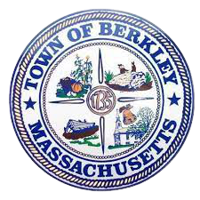 | Berkley Public Schools  21 North Main Street  Berkley, MA 02779  508-822-5220  508-823-1772 (fax)  www.berkleypublicschools.org | Melissa Ryan  Superintendent  mryan@berkleypublicschools.org  Melissa F. Coelho  Executive Assistant and  Human Resource Manager  mcoelho@berkleypublicschools.org

January 12, 2026
Dear Berkley Families and Community Members,
I am writing to share an important update regarding the Town of Berkley’s Fiscal Year 2027 (FY27) budget expectations and what they may mean for Berkley Public Schools.
Before the winter break, the Town Administrator issued formal guidance directing all departments to develop FY27 budgets based on a 6% reduction from current FY26 operating levels. For Berkley Public Schools, a 6% reduction would amount to more than $550,000 in cuts. This figure reflects only baseline operating reductions. It does not include known annual cost increases such as utilities, transportation, special education, and contractual salary obligations. In reality, the actual financial impact would be significantly greater than the 6% figure alone, and closer to $800,000.
Over the past several years, the cost of providing essential town services, including our schools, has continued to rise. At the same time, the Town’s current revenue structure has not kept pace with these increasing costs. While the Town has carefully managed expenses and relied on reserve funds to help close budget gaps, those reserves are limited and cannot serve as a long-term solution.
Town leadership is now preparing an override proposal as a proactive step to help lessen the impact of anticipated budget reductions and provide greater short-term stability for all municipal departments, including Berkley Public Schools. If approved, an override would help stabilize the Town’s finances for approximately four to five years and allow services to continue with fewer disruptions.
At the same time, this moment invites a broader community conversation about the true cost of operating our town and how we can work together to ensure Berkley remains a strong, sustainable community for our families, both now and into the future.
The actual FY27 school budget will not be finalized until late in the spring following a special election and Town Meeting. To ensure our community has access to accurate information and opportunities for dialogue, the FY27 school budget will be a standing agenda item at all upcoming School Committee Meetings. Below is a list of dates. Tonight’s meeting will be a joint meeting with the Board of Selectmen to begin a collaborative discussion on the FY27 budget. All School Committee Meetings begin at 6:00 pm and are held in the Berkley Middle School Library.
January 12, 2026 - Joint Meeting with the Board of Selectmen
February 9, 2026
March 16, 2026
April 13, 2026
May 18, 2026 - Tentative School Committee Vote on the FY27 Budget
June 1, 2026 - Meeting at 5:00 pm before Annual Town Meeting
In addition, we will host a series of Parent and Community Forums focused on the school budget. Our first forum will take place on Wednesday, January 21, 2026, at 7:00 p.m., with a virtual attendance option. These forums are intended to provide families and community members with clear information, answer questions, and create space for thoughtful conversation. More details will be shared soon.
We encourage families and community members to participate in these meetings and forums as we work together through this challenging budget season. If you have questions, please reach out.
Thank you for your continued partnership and for supporting our students and schools.
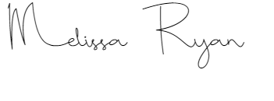
Sincerely,

Melissa Ryan
Superintendent

